Anindita Varshneya

**Test-driven development and new features improve GRNsight: a web application and service for visualizing small- to medium-scale gene regulatory networks**

The central dogma of molecular biology is the process of transcribing DNA into RNA, and then translating RNA into protein. Because proteins are the main functional unit within a cell, regulating the production of proteins is essential to proper cell function. Regulatory transcription factors (TFs) are the molecules within a cell that determine which genes in the DNA should be transcribed into RNA at a particular time. Regulatory TFs can either activate or repress the expression of a gene by binding to a site prior to the beginning of the gene on the DNA. However, the number of TFs in a cell is significantly fewer than the number of genes in the DNA that are regulated by these TFs, so one TF regulates multiple genes. In addition, TFs often use a process called combinatorial control, where multiple TFs bind together to collectively activate or repress the expression of a gene. TFs are themselves proteins, so the expression of the RNA that creates TFs is controlled by other TFs.

A GRN consists of a set of regulatory transcription factors and the relationships between them. (MacNeil et al., 2011). These interactions define the types and amounts of mRNA and protein produced by the cell. Using gene expression data, our sister project, GRNmap, performs parameter estimation and forward simulation of the expression of GRNs to explain how TFs interact with each other to regulate a biological response. GRNmap takes in an Excel file containing several sheets of necessary information to complete the estimation, and returns another Excel file that includes the user provided data as well as additional sheets with estimated parameters and data reflecting the model dynamics.

One common presentation of GRNs is in adjacency matrices, which include source genes and target genes listed across columns and rows respectively, and when the elements of the matrix indicate the relationship between these genes (Figure 1). GRNmap input files include unweighted adjacency matrices in which a “0” indicates no relationship between the corresponding genes, and a “1” indicates a regulatory relationship of some unknown magnitude and direction. GRNmap outputs a weighted adjacency matrix where each “1” is replaced by a more real number which indicates the magnitude of the relationship between the gene and its transcription factor; the sign of the number (positive or negative) indicates the direction of the relationship (activation or repression).

In order to most effectively and efficiently analyze biological data of this type, network visualizations are often used to demonstrate relationships between GRNs (Pastrello et al., 2013). These visualizations are often shown as graphs where nodes represent genes, and the edges between them represent their relationships. Manually creating these types of visualizations can be tedious and time consuming, so graph visualization software exists to streamline the analysis portion of GRN related research projects. Currently, several different programs exist that visualize network interactions including Cytoscape, Gephi, and yED. While each of these programs effectively diagram GRN visualizations, none of them address the niche case for GRNmap output sheets.

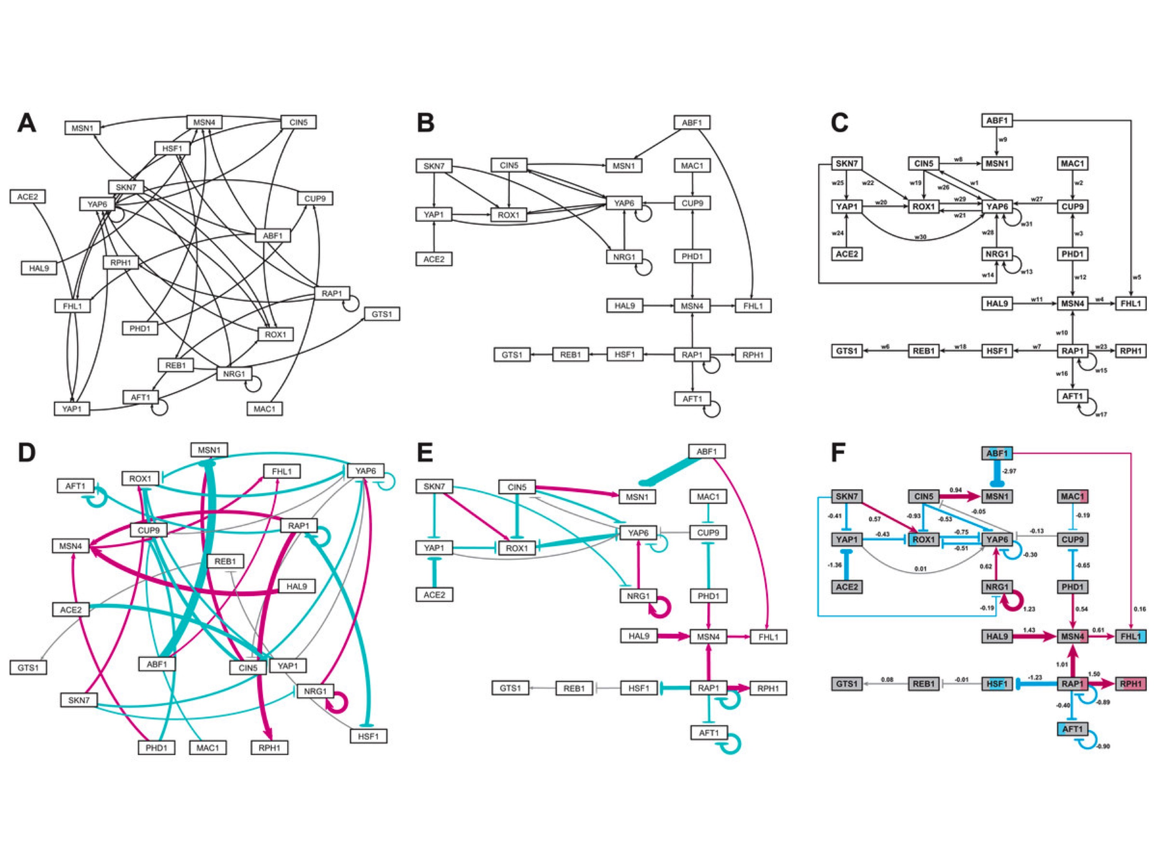

**Figure 1.** Medium-scale gene regulatory networks. (a) and (d) are unweighted and weighted gene regulatory networks, respectively, automatically produced on GRNsight within about 10 milliseconds. In the weighted network, magenta edges represent activating relationships, while cyan edges indicate repressing relationships. Grey edges indicate no substantial activation or repression relationship. The thickness of the lines in these networks indicates the magnitude of the relationship between the nodes. (b) and (e) are user manipulated unweighted and weighted networks, respectively. These graphs were produced in about 10 milliseconds, and took about 5 minutes of manual adjustment to create. (c) and (f) are unweighted and weighted, respectively, gene regulatory networks created on Adobe Illustrator. Each of these networks took several hours to produce. Node coloring in (f) was produced according to the software GenMAPP 2 (Salomonis et al., 2007), which shows expression levels of the gene at different time points throughout the course of the study. (Dahlquist et al., 2016)

Cytoscape is one of the best-known GRN visualization programs, and has tools that allow users to view and create large networks (Shannon et al., 2003). While Cytoscape is compatible with all of the file types GRNsight is also compatible with, Cytoscape does not take in adjacency matrices as a data structure, and is therefore not compatible with GRNmap generated output workbooks. In fact, because adjacency matrices are a format through which GRN data is presented, many users will need to reformat their data in order to successfully use Cytoscape. Furthermore, Cytoscape is a stand-alone program that a user must install onto her machine. While this may not always raise issues, in the context of a university-based lab, installing new software onto a university machine is often difficult and requires admin login information that is not available to students. Because Cytoscape can run as a stand-alone application, it comes with several options and features that allow users to customize their visualizations and get more information about their networks compared to other web-based programs. While this is beneficial in some cases, this complicates the learnability of the software, so it is not the best tool for novice users. Finally, Cytoscape is optimized to present visualizations for large-scale networks. While this is useful for understanding genome-level interactions, it is not as useful when analyzing individual processes, which produce small- to medium-scale networks.

Gephi is another popular software primarily aimed at visualization and explanation of large-scale networks (Bastian et al., 2009). While Gephi has high user tested learnability and effective user interface, it still faces several of the problems previously noted in regards to Cytoscape. Gephi also needs to be installed onto a user’s machine in order to be accessed. Despite simplifying the program and making it more accessible to the average user, Gephi provides several customization options that would only be beneficial when understanding large-scale networks. Ultimately, like Cytoscape, Gephi was created for researchers analyzing large amounts of data in large-scale networks, which does not address the key concern that led to the development of GRNsight.

Finally, yEd is another GRN visualization software program that allows users to upload Excel files or XML files containing adjacency matrices and produce directed graphs of that data (Wiese et al., 2004). This program allows users to customize the type of graph created (flowchart, family tree, semantic network, etc.) and also allows users to arrange and export their graphs easily. Unlike the previously mentioned software, yEd has a browser-enabled version of the application in addition to the stand-alone version that must be installed onto a users machine. In order to access the full version of the program, the user must install the program onto their machine and, in some cases, make additional payments. While yEd comes closest to addressing the chief concerns that led to the development of GRNsight, it does not provide a solution for each of the goals our research team had for creating GRN visualizations.

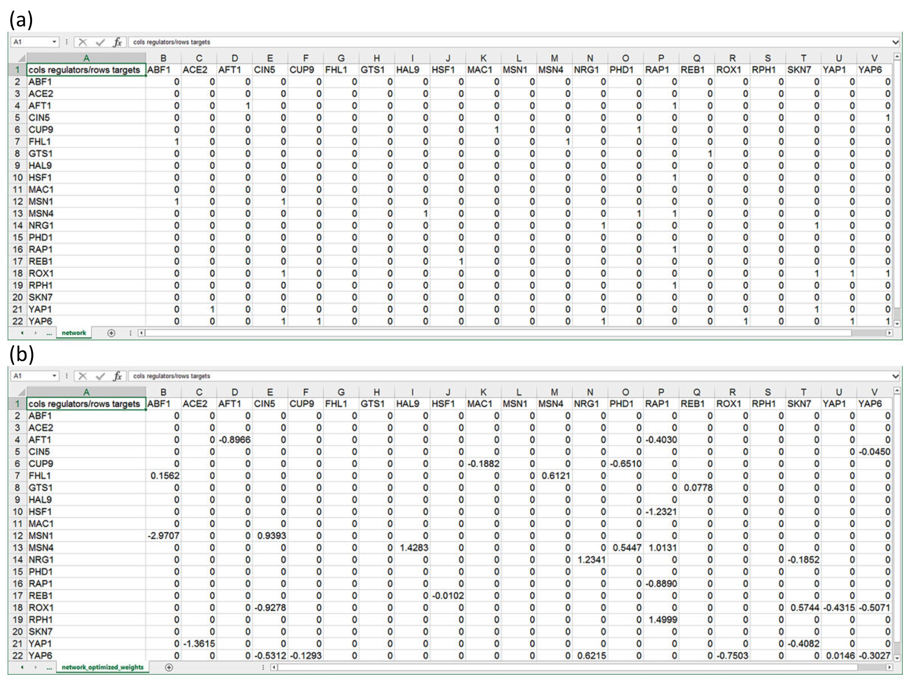

**Figure 2.** Properly formatted adjacency matrices that can be opened in GRNsight to generate network visualizations. All matrices are directed. Gene names in column headings represent regulators, and genes in row headings represent target genes. (a) An unweighted adjacency matrix where ‘0’ represents no regulatory relationship between the regulator and the target gene, and ‘1’ represents some regulatory relationship between the regulator and the target gene. (b) A weighted adjacency matrix where all ‘1’s were replaced with real numbers that indicate the direction and magnitude of the regulatory relationship between the corresponding genes. A positive number indicates that the regulator is an activator, while a negative number indicates that the regulator is a repressor. (Dahlquist et al., 2016)

In order to address the concerns that none of the previously mentioned programs adequately solved, the Dahlquist lab created GRNsight, a web application and service for visualizing small- to medium-scale gene regulatory networks with the following guidelines (Dahlquist et al., 2016):

* Exist as a web application that does not require installation.
* Have high learnability so that any novice user could quickly understand the program.
* Accept Excel files containing weighted or unweighted adjacency matrices similar to those produced by GRNmap, as well as other commonly used file formats (SIF and GraphML)
* Automatically produce small- to medium-scale, weighted or unweighted, directed network graphs that allow for easy and efficient analysis of biological data.

GRNsight effectively addresses these goals while also following open-source and software development best practices. GRNsight exists as a free, open source web application that accepts Excel files containing properly formatted adjacency matrices, GraphML data with properly formatted data descriptors, and SIF data where all data exists in tab-delimited columns in the production of GRN visualizations (Figure 2). The program uses a sophisticated server-oriented architecture where user provided data is sent to our GRNsight web API server to be parsed into a JSON object that is ultimately sent back to the web browser to be presented as a graph visualization. The user can then choose to export the data in SIF or GraphML formats, which sends the JSON data back to the web API server where is it converted into the requested data type (Figure 3). Once uploaded to the web browser, visualizations can be customized using Force Graph Parameters that sit on the left-hand side of the screen (Figure 4). Additionally, nodes have drag and drop properties that allow users to manipulate graphs and adjust them to their liking. Double clicking on a node releases it from its “dropped” location, and allows the node to respond to any changes the user might make in the Force Graph Parameters.

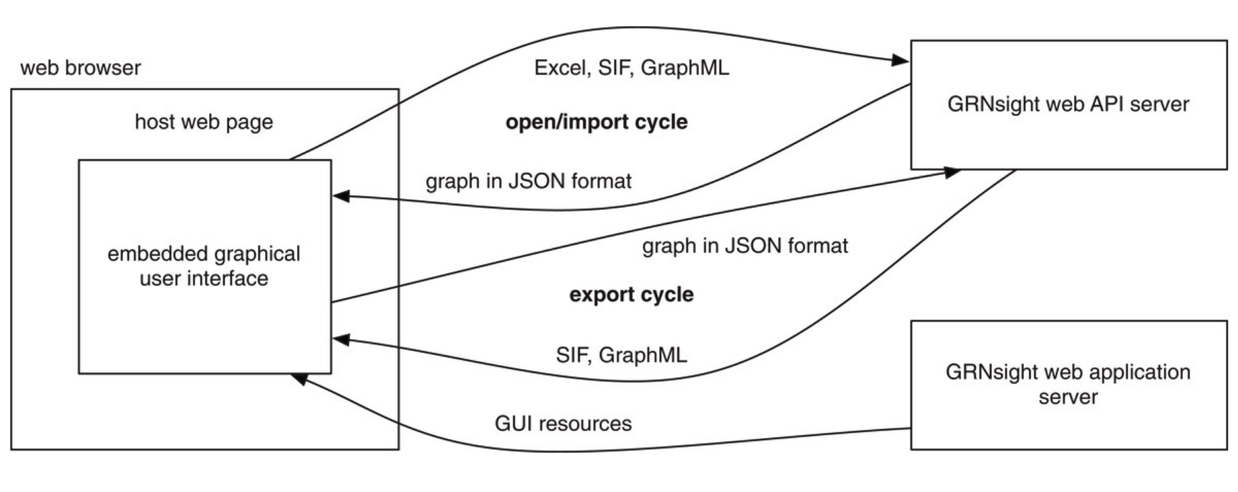

**Figure 3.** GRNsight has a complex, server-oriented architecture. The web browser holds the web page and the embedded graphical user interface. When a network spreadsheet is opened on GRNsight, the GRNsight web API server parses the spreadsheet and sends it back to the web browser in JSON format, where it is interpreted and visualized. If a graph is exported from GRNsight, it is returned to our GRNsight web API server in JSON format, converted into the desired file format, and returned to the user interface. (Dahlquist et al., 2016).

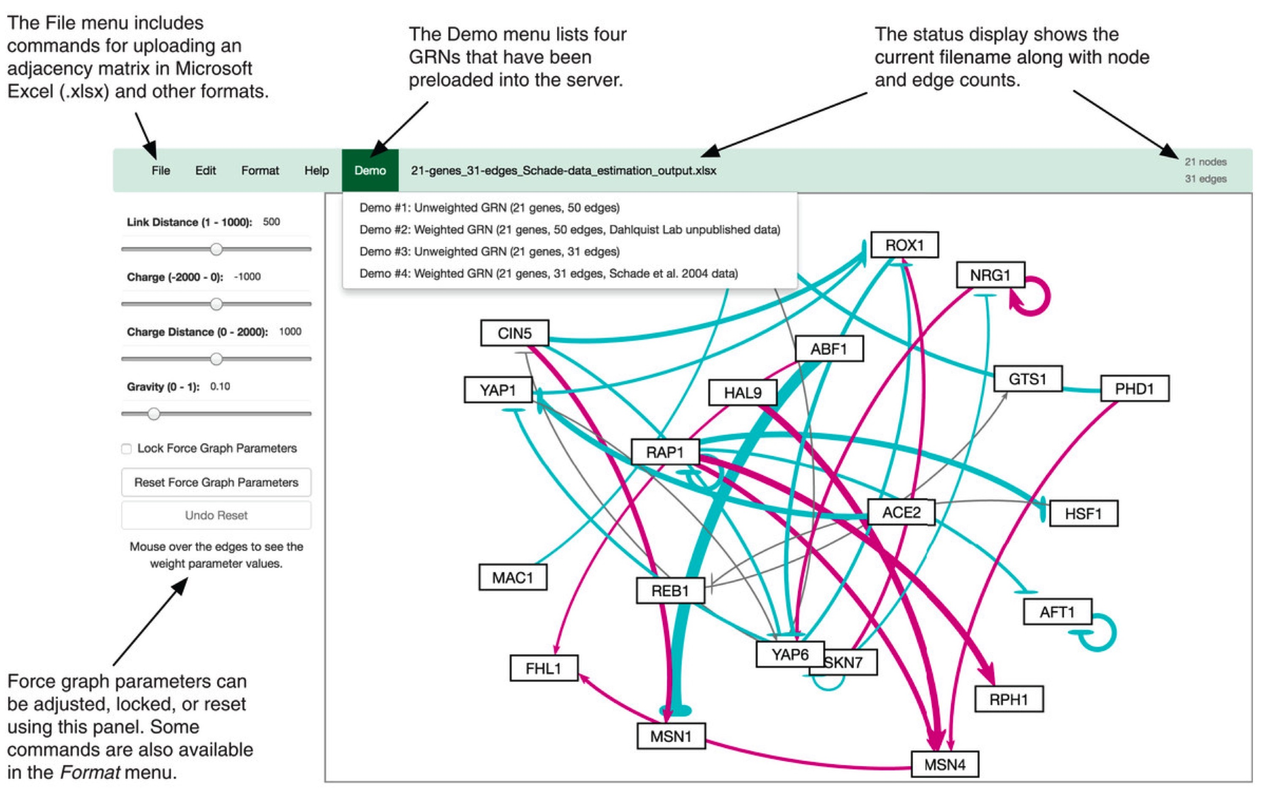

**Figure 4.** An annotated screenshot of the GRNsight user interface. The file menu at the top left of the screen provides commands for uploading an adjacency matrix in Microsoft Excel (.xlsx) and other formats. The demo menu provides four sample adjacency matrices stored on the server. The status bar allows users to see which sheet is currently open in the viewport, and how many genes and edges are in that network. Force graph parameters on the left-hand side of the screen can be adjusted, locked, or reset according to user’s preference. (Dahlquist et al., 2016).

Most recently, improvements to GRNsight include the integration of Test-Driven Development (TDD), descriptive error and warning messages, and other front-end options that allow users to customize the appearance of their network.

Testing Framework

In order to ensure that GRNsight is running as expected, and that all relevant errors and warnings within the program are caught accurately, the GRNsight team implemented Test Driven Development (TDD) for GRNsight. TDD is a software development best practice that encourages the developer to make changes incrementally to their program to ensure that it is running expectedly through the mechanism of unit tests (Bissi et al., 2016). More explicitly, a unit test ensures proper behavior for a particular unit of code. Often, a single new functionality requires tens of unit tests because each step of that functionality is tested separately.

The TDD process begins when the developer writes a unit test for new functionality before coding that functionality into the program itself (Figure 6). This means, at first, the test will fail. Then, the developer should proceed to write code to implement the new functionality. If the new code was written according to the predetermined expectations as outlined by the unit test, the test should pass. At this point, the developer can go back and refactor the code to ensure it runs efficiently and is easily understandable. This process is especially important for academic research projects, such as GRNsight, because it ensures that we maintain consistent levels of internal software quality and facilitates repeatable and reproducible research. (Bissi et al., 2016).

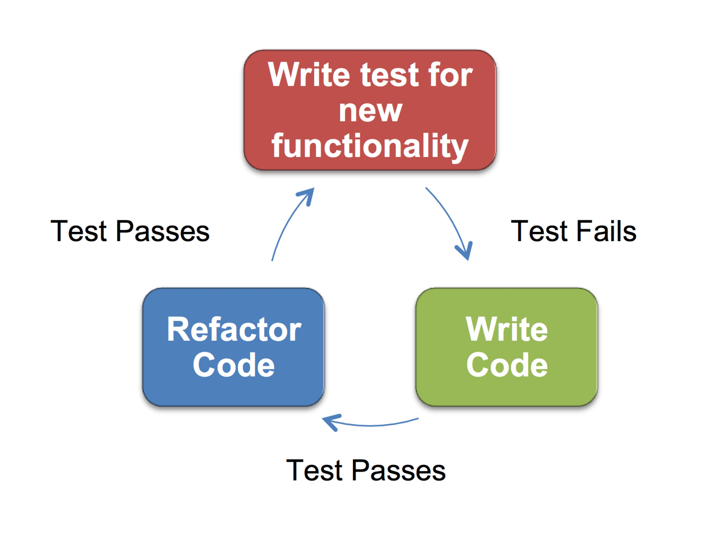

**Figure 6.** The test driven development (TDD) cycle. The process begins with writing a test for new functionality prior to writing the code for that functionality (red). Initially, the test will fail. Then, code for the functionality is written, and if it is written according to the expectations outlined in the unit test, the test will pass (green). Then, the programmer can refactor the code to make it efficient and easily understood, at which point the test should continue to pass (blue).

To implement TDD into GRNsight, about 500 sample Excel workbooks with adjacency matrices were created to test for the various possible edge cases. These included tests for length and composition of gene names, adjacency matrix modifications, missing or extraneous matrix data, formatting, and special characters. Because the team’s main priority was to ensure that user-provided data was parsed through correctly, all current unit tests exist on server side functions to confirm that the output graph is accurate and a good representation of the adjacency matrix. Unit tests are executed using Mocha, a JavaScript test framework running on node.js, and are written using Chai, an assertion library for node.js.

A number of test functions were created that each check for proper functionality of specific errors and warnings returned to the user. In general, these test functions check for the frequency of a particular error or warning code, which is added to the errors or warnings array within the network object at detection of a mistake. Many test functions also gather additional information such as the exact location of any identifiable mistake, or the name of the affected gene. This additional information confirms that the spreadsheet parser catches the errors and warnings correctly. Each of the 500 manually created Excel workbooks are tested via 230 passing unit tests in the beta version of GRNsight (v2.0.1). Prior to our unit testing framework, each of these matrices were manually checked for functionality by uploading each sheet into GRNsight and ensuring that all aspects of the program cooperated with that sheet. Figure 6 shows that since implementing unit tests, coverage across all aspects of our code ranges from 68 to 85% (Table 1).

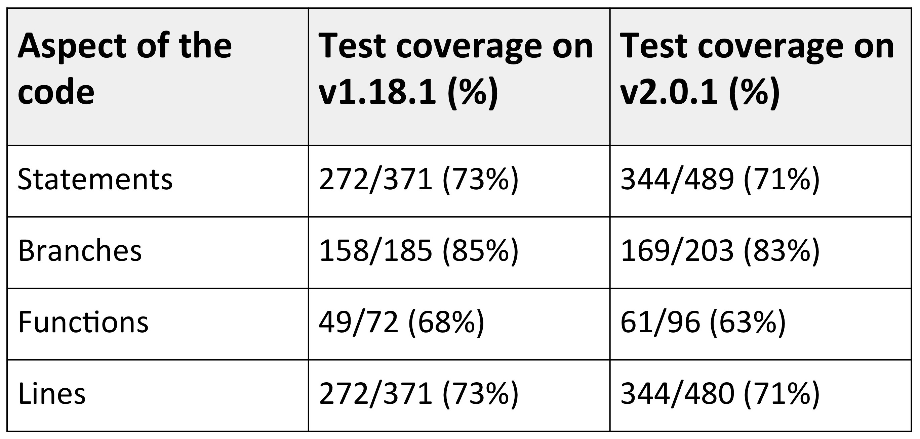

**Table 1.** Test coverage statistics in the master (v1.18.1) and beta (v2.0.1) versions of GRNsight. There is consistent coverage across all sections of the code. Code coverage decreased slightly between the two version because the project is in active development. Some test-last development (TLD) had to occur due to deadlines for our most recent publication. (Dahlwuist et al., 2016)

The consistent use of TDD through all server-side functionality in GRNsight ensures that all of the errors and warnings are caught and treated as expected. Furthermore, TDD ensures that all functionality internal to the program is functioning as expected.

Implementation of TDD to projects such as GRNsight is essential in ensuring the quality of the program and the corresponding visualizations. It was found in analyses of 27 different programs, made either in industry by professionals or in academia by students, that TDD improved both the internal and external quality of the program (Rafique et al., 2013). Across a majority of these projects, the use of TDD also correlated with a decrease in productivity. However, only one in nine academic projects reported decreased productivity upon implementation of TDD (Rafique et al., 2013). GRNsight is still in the process of optimizing the unit-testing framework, so it is difficult to say whether implementation of TDD has truly slowed down the productivity of the programmers. That said, because GRNsight is mainly used for analysis of biological data, the importance of accuracy in our visualizations outweighs the importance of quick implementation of functionality.

Whether or not TDD slows down productivity in the production of new functionality, it is essential to the program that all code functions as expected and is checked for proper functioning immediately as it is written. Test last development (TLD) offers too many opportunities for unit tests to conform to the expectations of the developer of the functions of the preexisting code, and therefore does not ensure the same level of quality that TDD does. While implementation of TDD has been a long process, it has been essential for the integrity of the visualizations produced by GRNsight, and ensures that GRNsight conforms to software engineering best practices.

Errors and Warnings Modal

To ensure that the graphs we present on GRNsight are accurate, two systems were put in place: error and warning catchers. Errors represent fatal mistakes in the adjacency matrix. These mistakes are fatal because they either cause the program or server to crash, or they cause the visualizations to be inaccurate. In the case of an error, an error code is added to an errors array within a network object in the spreadsheet parser, and the entire network is returned without creating graph visualization. Instead, a three-part error modal appears on screen to inform the user: a) there was a problem when GRNsight tried to upload their adjacency matrix, b) where the problem was, and c) how the user can attempt to fix it (Figure 5). The purpose of the three-part error/warning message framework is to ensure that all error messages are precise and constructive, so users understand exactly where the problem is and how they can fix it. Furthermore, all messages were written so that lay-users could understand the entirety of the message. These characteristics are essential for a positive human-computer interaction as they ensure the user will be able to benefit from the message (Molich et al., 1990).

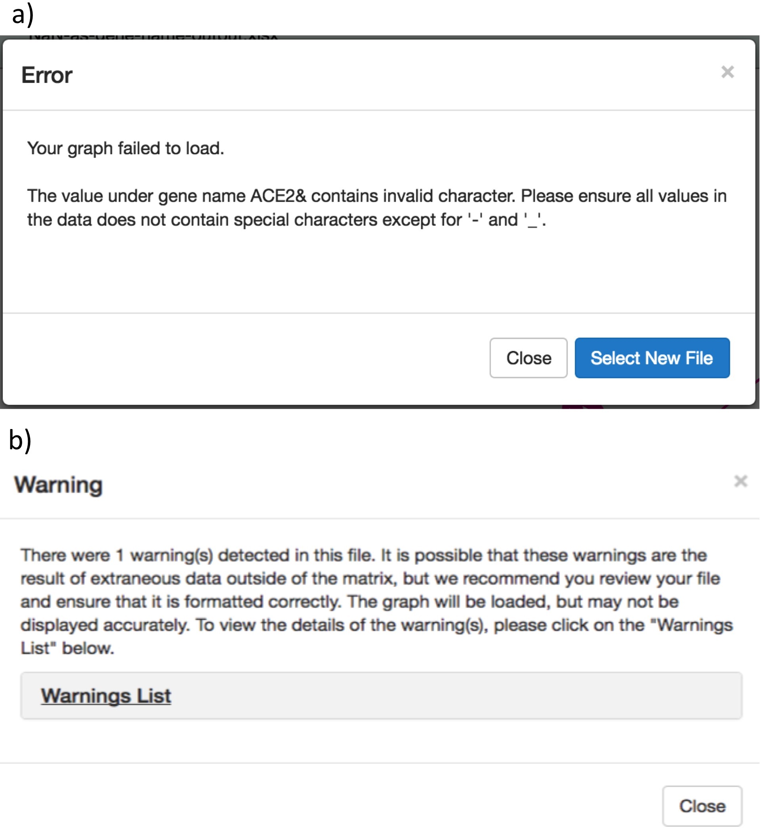

**Figure 5.** Error and warning modals. (a) The error modal features a three-part message to the user that explains what the problem is, why the problem exists, and how the user can approach solving the problem. It also features a button that allows users to easily upload a new file. (b) The warning modal features a similar three-part message as the error modal. It explains what the problem is, including why these problems are issued as a warning as opposed to an error. The collapsible “Warnings List” contains additional details about what the problem is, and how the user can approach finding the problem and fixing it.

Conversely, non-fatal problems in the user provided adjacency matrix return a warning to inform the user of the potential problem, but the graph is still presented because it is presumed that the mistake does not compromise the integrity of the program. GRNsight presents the user with a warning modal similar to the error modal that indicates that there is a non-fatal mistake in her adjacency matrix, what the mistake is, and how she can fix it. Users can click out of the warnings modal and view and analyze the graph, but have the opportunity to open the window once again with a link that exists underneath the Force Graph Parameters on the left-hand side of the screen. Because the mistakes that cause warnings to show are non-fatal to the spreadsheet parser, GRNsight allows the visualization to continue, but informs the user that there may be mistakes in the visualization.

The errors system was expanded so if a user attempts to upload an adjacency matrix that is improperly formatted or contains fatal issues that would compromise the accuracy of our visualization, GRNsight reject’s the adjacency matrix and returns an error modal that indicates the problem and a possible solution. The modal exists as a closable window in the middle of the user interface. While an error system was put in place prior to my joining on the project, the errors that were checked within the spreadsheet parser were limited. Warnings are a brand new addition to the GRNsight program. Non-fatal problems in the user provided adjacency matrix return a warning to inform the user of the potential problem, but the graph is still presented because it is presumed that the error does not compromise the visualization overall.

To improve our error and warning checking system, we considered a number of edge cases, which represent a variety of mistakes a user might make when constructing the adjacency matrix prior to uploading it to GRNsight.

**Network Sizes**

Because GRNsight was optimized for small- to medium-scale networks, there is a maximum for the number of nodes and edges that the program will accept. If a user attempts to upload a graph larger than 75 nodes or 150 edges, the program returns an error to let the user know that the graph is too large. The program limits the number of nodes and edges to this value because at this point, the visualizations on GRNsight become increasingly difficult to interpret. As the number of nodes and edges increases, the user is not able to distinguish between the different edges and discern how they connect to one another. Furthermore, very large networks cause our server to crash. The network size error ensures that GRNsight is being used with an appropriate number of nodes and edges, and ensures that the visualizations produced by the program are accurate and readable.

While GRNsight will not return an error until 75 nodes or 150 edges is reached, the program was optimized to work with no more than 35 nodes or 70 edges. If the user attempts to upload a network with less than our recommended number of nodes and edges but fewer than the maximum, an accurate graph visualization will still appear, but the program informs the user that the quality of the network graph may be compromised.

**Corrupt Gene Names**

Corrupt gene name errors occur when users attempt to upload an adjacency matrix where the gene names are either too long or contain a special character other than a number, a dash (“-“), or an underscore (“_”). Currently, our spreadsheet-parsing algorithm does not accept special characters, so uploading a spreadsheet with incorrect gene names would cause our program to crash. Additionally, long gene names cannot be presented within the nodes of our visualizations without stretching them to a point that they no longer fit the aesthetic requirements of our graphs.

**Missing Gene Names**

Missing source genes and missing target genes within the adjacency matrix cause a warning to be issued because, by default, our spreadsheet parsing algorithm assumes that any data underneath those missing gene names are irrelevant, and does not attempt to diagram them. Because this type of error is handled in our parser, and because all data provided by the user is presented accurately, we can issue a warning. This warning message is uniquely customized to include the exact cell that is missing data in the matrix to allow the user to quickly find the cell in their spreadsheet and act accordingly.

**Duplicate Gene Names**

If the identical gene name is duplicated within the source genes or the target genes (i.e. if there are two Abc1 genes listed as source genes) in the adjacency matrix, a duplicate gene error is triggered. If two genes of the same name are listed within the matrix, our program will be unable to distinguish between the two genes when creating the visualization. Because this would make our program crash, this is considered a fatal error.

**Data Type**

Microsoft Excel allows users to customize the data type of each cell in spreadsheets. Often, this causes the data within the cell to change format. For example, if the user has the value ‘0’ in a cell in the adjacency matrix, and changes the data type of that cell to “Time,” the value in the cell would change to ’00:00:00.’ Because GRNsight was created to only handle simple numerical relationships between genes, this format would cause the parser to crash, and therefore cause the program to crash. These types of fatal errors are caught as incorrect data type errors and are presented to users as such.

**Missing Data**

Finally, we created and error handler for the edge case where a user is missing data in an entire row in the adjacency matrix. We anticipate that this could be because a row of data is actually missing within the worksheet, or that the user has some stray data in her worksheet that is being picked up by our spreadsheet parser. In the first case, we want to make sure that the user is aware of the missing data so she can either populate that row correctly, or delete that row altogether. In this case, the error in the sheet is truly an error and the user should correct her adjacency matrix to ensure that the visualizations are accurate, so the program returns an error to the user and the visualization is not presented.

In the second case, the user may have accidentally input data in a random cell in the sheet several rows away from the adjacency matrix. Because Excel spreadsheets contain up to 1,048,576 rows, random or accidentally typed data could potentially exist in a very large number of cells. Only one cell needs to carry extraneous data for GRNsight’s spreadsheet parser to catch it. For this reason, the GRNsight coding team implemented a strictness parameter that determines whether or not the extraneous data is considered a mistake or intentional. Every row between the adjacency matrix and the extraneous data is considered a “missing row.” Therefore, if extraneous data exists 5 rows below the adjacency matrix, the spreadsheet parser would issue 5 missing row notifications to a counting function. Once the counting function indicates a number of notifications that exceeds the number in our strictness parameter, we change the type of notification we provide to the user from a warning to an error.

Currently, the strictness parameter is set at 25. If there are fewer than 25 missing row notifications counted by our spreadsheet parser, GRNsight assumes that the extraneous data was either written on purpose by the user, or is close enough to the adjacency matrix that the user could easily find it. Because of these conditions, if there are fewer than 25 missing row notifications, GRNsight informs the user that there is an error with their spreadsheet because of extraneous data. Conversely, if there are 25 or more missing row notifications, GRNsight assumes that the extraneous data was added accidentally, or that it is too far away from the adjacency matrix for the user to find it easily. In this case, GRNsight issues a warning that tells the user where the extraneous data is, and continue to present the graph disregarding the extraneous data.

**Missing Adjacency Matrix Data**

Missing adjacency matrix data represents an instance where a user leaves a single cell within the adjacency matrix empty. By default, JavaScript assumes the empty cell to have a value of 0 and the spreadsheet parser acts accordingly. Because this type of mistake fits the requirements for a warning, displays the graph, and lets the user know that there might be something wrong. Once again, a specialized error message that tells the user the exact cell with missing data, so adjustments, if necessary, can be made quickly.

These errors and warnings are essential to ensure that the program itself will not fail if a user uploads an improperly formatted adjacency matrix, and that the visualizations that GRNsight provides to users are accurate for the data provided. The informative three-part message in the errors and warnings modal allow users to fix any potential issues in their spreadsheets with ease, and continue working with the program. Prior to these additions to the GRNsight project, the spreadsheet parser only considered a few major edge cases, and did not have any warnings. Supplementing the previously created error list with additional error edge cases means that a substantially heighted quantity of mistakes in adjacency matrices can be caught. Handling of these mistakes improves the integrity of the project overall, as the entire program is less likely to crash in the event that a user attempts to upload an incorrectly formatted adjacency matrix.

Both the error and warning handling systems are essential to communicating to the user when GRNsight does not function exactly as it is supposed to. However, these systems are only as useful as the messages they provide to the user. If the user does not understand why GRNsight did not upload her adjacency matrix as she expected, the importance of the error and warning handling systems are diminished.

Moving forward in this aspect of the project, it would be beneficial to explicitly explain to the users how the potential problems in the adjacency matrix might affect the graph visualization in the event that the mistake only invokes a warning. For example, if a user uploads an adjacency matrix with a missing target gene name, it would be beneficial to inform the user that any regulatory relationships that influences the gene that belongs in the missing cell will not be presented in the visualization. This would not only make our warnings messages more comprehensive, but it would present all information in an easy to understand format for lay-users.

Front End Features

In addition to the errors, warnings, and unit tests, several front-end features were added to improve graph visualizations and allow users to further customize the network graphs. At GRNsight’s conception, it was decided that all weight data would be normalized and be presented as 12 distinct edge thicknesses. Each of these edge thicknesses has an end pointer proportional to the edge thickness, either an arrowhead or a perpendicular blend end marker. Arrowheads as associated with pink edges, and indicate an activating relationship between the corresponding nodes, while blunt end markers are associated with cyan edges, and indicate a repressing relationship between the corresponding nodes. Initially, all arrowheads were configured to sit at the end of the edges with the same centering parameter. This became problematic, however, because arrowheads aligned differently on each of the edge thicknesses. An important aesthetic feature that was adopted in order to combat this problem was giving each edge thickness and its corresponding arrowhead a different centering parameter. While this was supposed to fix the problem of centering arrowheads on edges, it was found that self-referential edges required their own centering parameter as well. After customizing each centering parameter according to the edge thickness and edge type, all arrowheads are properly centered.

Centering arrowheads to the edges was a purely aesthetic decision. Arrowheads were centered to each edge weight separately because using the same centering parameter across all edge weights resulted in off-center arrowheads on thicker edge weights. This adjustment was an important addition to the GRNsight graph visualization because one of the key aspects of GRNsight’s design is that graphs are quick and simple to produce, and are visually appealing.

Furthermore, a new feature was recently added to v2.0.1, that allows users to always show edge weights via a floating number at the center of the edge, always hide edge weights, or to only show edge weights upon mouse over via a small tooltip that appeared at the bottom right corner of the pointer on weighted graphs (Figure 7). Because unweighted graphs do not have specific edge weights, this functionality does not exist on unweighted graphs. Without this functionality, edge weights could only be observed one at a time, making it difficult to compare weight values between two edges.

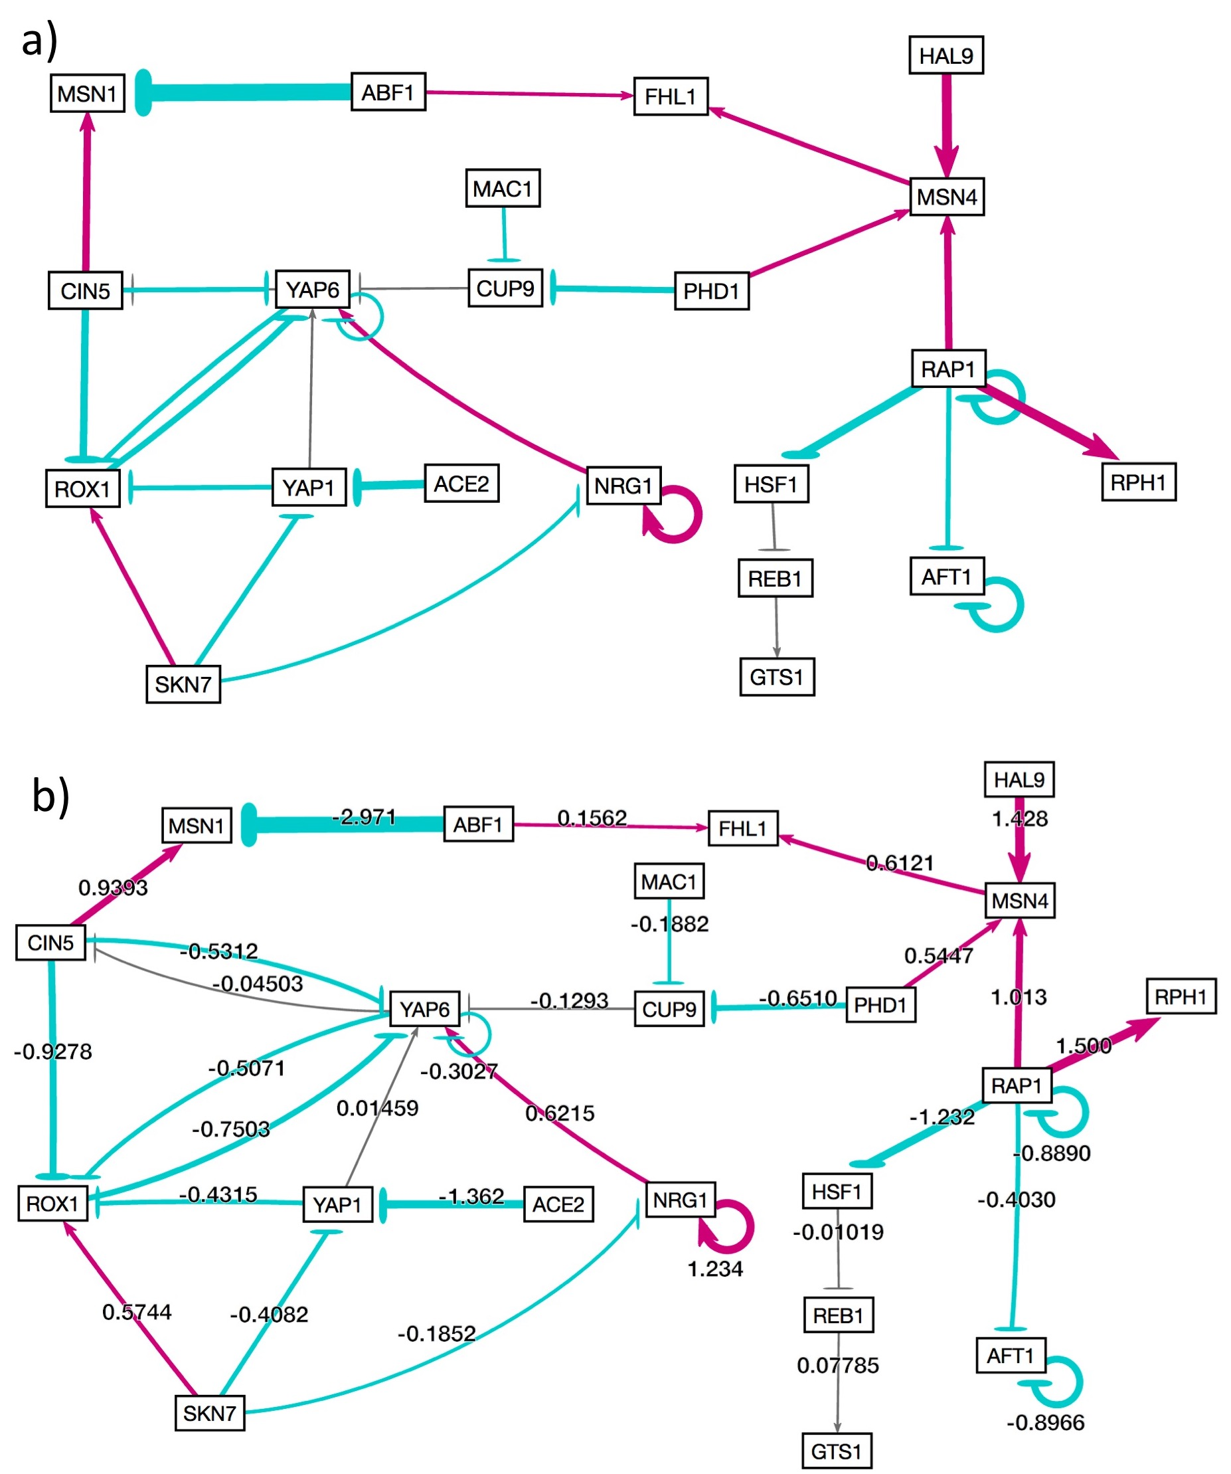

**Figure 7.** Showing and hiding weights. When an adjacency matrix is uploaded to GRNsight, default functionality is to only show weights upon mouse over in a tooltip that appears on the bottom right corner of the pointer. The user can select to always have weights hidden using menu options that exist in the left side bar, and under the Format tab in the file menu. In either case, the network graph would appear as it does in (a). If the user chooses to always show weights, the data would appear in the center of each edge as show in (b).

When presenting and analyzing networks, it is often beneficial to see both graphic displays of the regulatory relationships (i.e. via color coded edges with varying thicknesses) as well as numerical weights. Allowing users to always show weights means they can easily interpret their graphs without having to mouse over each individual edge. Additionally, hiding all weights can be beneficial if the user chooses to not have extra data cluster the visualization.

Another important reason for users to be able to always show weights is because it allows users to compare networks fairly. If two different networks are generated using GRNsight, in order to compare the graphs with each other, the user must be able to look at the numerical values of each edge to understand how the different regulatory relationships differ from each other. A new feature has been implemented is customization of the normalization factor. While users can currently compare numerical weight data using the “always show weights” setting, this does not modify the thickness of the edges in the network itself.

By default, GRNsight determines the smallest and largest value in an adjacency matrix, and normalizes those weight values to fit within twelve distinct edge thicknesses corresponding to the strength of the regulatory relationship. However, with this model a graph with edge weights -1 to 1 could appear similar to a graph with edge weights -10 to 10. Allowing users to adjust the normalization factor means users can select the maximum edge weight encompassing both networks they wish to compare, and edge thicknesses will be adjusted according to a range from 0 to the user defined maximum value. If a user inputs the same normalization factors into our user interface, the edge thicknesses will automatically adjust according to that factor. If multiple graphs are adjusted to the same normalization factors, the edge thicknesses of those graphs will become entirely comparable. Customization of normalization factors will be achieved using both minimum and maximum edge weights from all comparable networks. The range of edge weights will be compartmentalized into twelve edge thicknesses using D3.js, and the resulting visualization will use edge weights according to the newly compartmentalized weight-to-edge thickness settings.

**Conclusion**

TDD, error and warning catchers, hiding and showing weights, and normalization of edge thicknesses are necessary and indispensable additions to the GRNsight project. These additions not only conform to software engineering best practices, but also improve user experience overall. The expanded error and warning handling system encompasses several new edge cases ensures that GRNsight runs correctly, and ensures that visualizations on GRNsight are created accurately. TDD encourages student programmers on the project to code new unit tests prior to coding new functionality, which promotes the internal and external quality of GRNsight code. Finally, adjustments to the visualization for aesthetic reward and customization of the appearance of edge weights means users can create network graphs for different uses, and compare several networks more easily.

Moving forward, customizable normalization factors will continue to improve GRNsight, and will be a new feature in v2.0.1. Additional improvements to GRNsight could include options for users to save their session on GRNsight, and later reupload it such that the same graph visualization appears in the same configuration the user left it. Improvements to how the graph viewport automatically adjusts precisely the size of the users screen could minimize any extra scrolling that might be required by the user, and could improve the aesthetic of the website overall. Finally, GRNsight could further improve presentation quality by making graph visualizations touch compatible, therefore allowing visualizations to be manipulated on a tablet. This feature allows researchers to more easily manipulate their graphs, and increase user experience overall.

**References:**

Bissi, W., Neto, A. G. S. S., & Emer, M. C. F. P. (2016). The effects of test driven development on internal quality, external quality and productivity: A systematic review. *Information and Software Technology*, *74*, 45-54. doi: 10.1016/j.infsof.2016.02.004

Bastian, M., Heymann, S., & Jacomy, M. (2009). Gephi: an open source software for exploring and manipulating networks. *International AAAI Conference on Web and Social Media*. *8*, 361-362. Retrieved from http://www.aaai.org/ocs/index.php/ICWSM/09/paper/view/154

Dahlquist, K. D., Dionisio, J. D. N., Fitzpatrick, B. G., Anguiano, N. A., Varshneya, A., Southwick, B. J., & Samdarshi, M. (2016). GRNsight: a web application and service for visualizing models of small-to medium-scale gene regulatory networks. *PeerJ Computer Science*, *2*, e85. doi: 10.7717/peerj-cs.85

MacNeil, L. T., & Walhout, A. J. (2011). Gene regulatory networks and the role of robustness and stochasticity in the control of gene expression. *Genome research*, *21*(5), 645-657. doi: 10.1101/gr.097378.109

Pastrello, C., Otasek, D., Fortney, K., Agapito, G., Cannataro, M., Shirdel, E., & Jurisica, I. (2013). Visual data mining of biological networks: one size does not fit all. *PLoS Comput Biol*, *9*(1), e1002833. doi: 10.1371/journal.pcbi.1002833

Shannon, P., Markiel, A., Ozier, O., Baliga, N. S., Wang, J. T., Ramage, D., ... & Ideker, T. (2003). Cytoscape: a software environment for integrated models of biomolecular interaction networks. *Genome research*, *13*(11), 2498-2504. doi: 10.1101/gr.1239303

Wiese, R., Eiglsperger, M., & Kaufmann, M. (2004). yfiles—visualization and automatic layout of graphs. In *Graph Drawing Software* (pp. 173-191). Springer Berlin Heidelberg. doi: 10.1007/978-3-642-18638-7_8